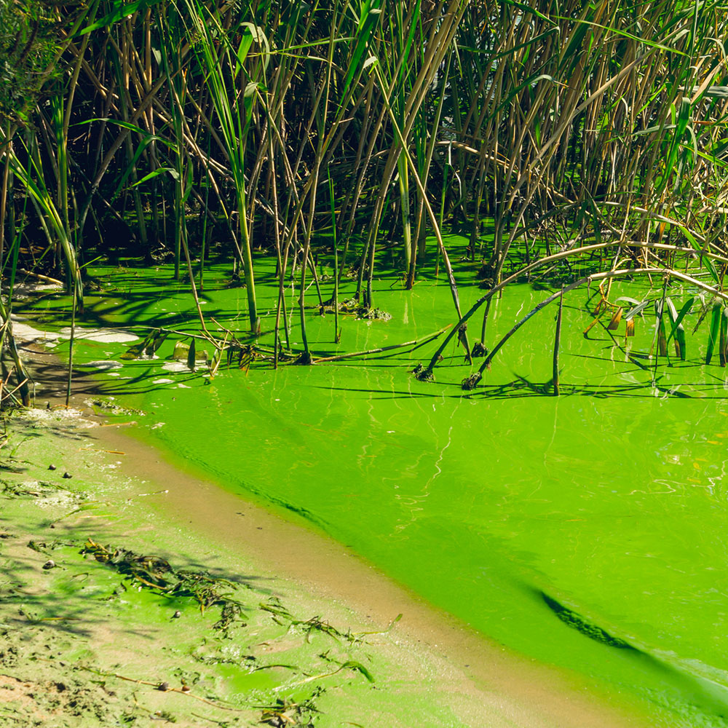  algae bloom predictibility with machine learning | Ava Ghannam & Mia Geudtner  EGN 4930 / EGN 5932C Environmental Data Science

Abstract
This study analyzes machine learning’s ability to predict nearshore harmful algae bloom occurrence associated with Karenia brevis. Using 1,617 observations of weekly environmental data, including physical, chemical, and hydrological variables, a Random Forest classifier was trained and tested. The model performance was evaluated under multiple configurations, including threshold adjustment, incorporation of lagged environmental variables, and SMOTE-based oversampling to address class imbalance.
The results display a baseline model underpredicted the algal bloom events. During the evaluation, reducing the classification threshold significantly improved the accuracy of bloom detection but simultaneously decreased the precision. Additionally, incorporating 1-week lagged variables improved the overall model performance. The SMOTE-enhanced model achieved the greatest recall and accuracy. The next best was the ROC-AUC model, but it came with increased false positives.
The SHAP analysis reported that physical drivers, specifically water temperature and sea surface height anomaly, had a stronger influence on the bloom prediction than chemical drivers such as nutrient concentrations. Overall, the study highlights the higher dependency on physical than chemical conditions as inputs, as well as the risk of sacrificing sensitivity to increase the model’s predictability.

Introduction
Harmful algal blooms (HABs), commonly referred to as red tide, pose significant ecological, economic, and public health risks along Florida’s Gulf Coast, which experiences the most devastating HAB internationally every summer. These events are primarily caused by a dinoflagellate named Karenia brevis, which produces brevetoxins. These toxins accumulate inside smaller fish, causing the fish to become poisonous; this transfers the toxins around the food web to impact larger animals such as manatees, dolphins, turtles, many of which are threatened with extinction. Additionally, it costs the US economy millions of dollars every year by disrupting fisheries and tourism, increasing respiratory visits to the emergency room, and much more. (NOAA Fisheries)

According to the Florida Fish and Wildlife Conservation Commission, red tides usually develop 10-40 miles offshore, and there is no direct link between anthropogenic nutrient inputs and the initiation of offshore Karenia brevis blooms. However, as blooms move inshore, they begin to utilize both oceanic and land-based nutrients to intensify. This complexity highlights a key challenge: HAB formation and persistence are not driven by a single factor, but rather by the interaction of physical, chemical, and biological processes.

Even with extensive monitoring efforts, predicting algae bloom occurrence remains difficult due to the complex relationships among physical, chemical, and hydrologic conditions. Traditional approaches can oftentimes struggle to successfully analyze these results, resulting in the need for predictive methods to evolve and improve the accuracy of algal bloom predictions.

2. Methods

2.1 Study Design
This study developed an interpretable machine learning framework to classify nearshore harmful algal bloom (HAB) presence associated with Karenia brevis using weekly environmental data around the Gulf Coast. The objective was to predict bloom conditions based on watershed inputs, hydrologic conditions, and coastal environmental variables while maintaining model interpretability.

2.2 Data and Variables
The dataset consisted of 1,617 weekly observations and included K. brevis concentration (kb) alongside environmental predictors: sea surface height anomaly (zos), salinity, water temperature, wind direction, wind speed, Peace River discharge, total nitrogen (peace_TN), and total phosphorus (peace_TP).
A binary bloom variable was created such that:
- 0 = < 100,000 cells $L^{-1}$(no bloom)
- 1 = $≥$ 100,000 cells $L^{-1}$(bloom)

2.3 Data Processing and Partitioning
The time variable was converted to a datetime format, and the dataset was sorted chronologically. An 80/20 chronological split was used to separate the training and testing of data, preserving temporal structure and preventing data leakage.
The predictor matrix included eight environmental variables, and no scaling or transformation was required due to the use of a tree-based model.

2.4 Baseline Model
A Random Forest classifier was implemented using 300 trees, a maximum depth of 10, and a fixed random seed (42). Class imbalance was addressed using class_weight = “balance”.
Model performance was evaluated using accuracy, precision, recall, F1-score, ROC-AUC, and confusion matrices.

2.5 Model Interpolation
Model interpretability was assessed using SHapley Additive exPlanations (SHAP). SHAP values were computed using TreeExplainer and used to evaluate both global feature importance and individual prediction behavior. Dependence plots were generated for key variables, including salinity, water temperature, total nitrogen, and total phosphorus.

2.6 Threshold Adjustment
To improve detection of bloom events, the classification threshold was reduced from 0.50 to 0.30. This adjustment increased sensitivity to bloom conditions and allowed evaluation of tradeoffs between recall and precision.

2.7 Lagged Feature Model
To account for delayed environmental effects, 1-week lag variables were created for total nitrogen, total phosphorus, and water temperature. Rows with missing values introduced by lagging were removed.
A second Random Forest model was trained using the original predictors plus lagged variables, using the same hyperparameters and evaluation approach.

2.8 SMOTE Oversampling
To further address class imbalance, SMOTE was applied to the lagged training dataset. Synthetic minority-class samples were generated to improve model sensitivity to bloom events. The model was retrained on the balanced dataset without class weighing.

2.9 Computational Environment
All analyses were conducted in Python using Jupyter Notebook with pandas, numpy, scikit-learn, imbalanced-learn, SHAP, and matplot.

3. Results and Discussion

3.1 Baseline Model Performance
This baseline Random Forest model demonstrated moderate classification performance when evaluated using the default probability threshold of 0.50. While overall accuracy was acceptable, the model showed limited ability to correctly identify bloom events, as reflected in relatively low recall for the bloom class. This indicates that the model tended to underpredict bloom conditions, favoring non-bloom classifications.
Reducing the classification threshold from 0.50 to 0.30 resulted in a noticeable improvement in bloom detection. Recall for the bloom class increases, indicating that more true bloom events were correctly identified. However, this improvement came at the cost of reduced precision, as the model produced more false positives. This tradeoff reflects a common challenge in environmental classification problems, where missing critical events such as harmful algal blooms can be more consequential than overprediction.
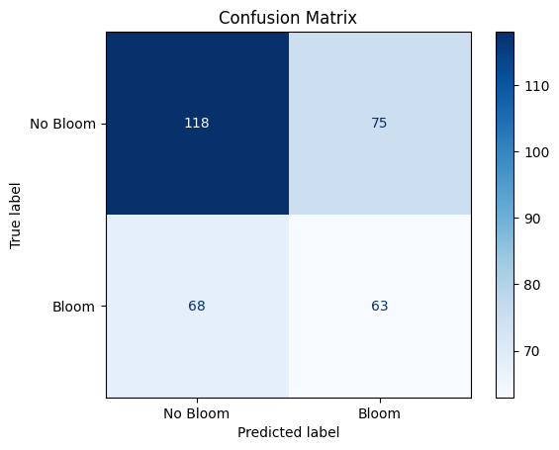
Figure 1. The baseline model shows moderate overall performance but struggles to identify bloom events, as indicated by a high number of false negatives. This suggests the model tends to favor non-bloom classifications under the default threshold.

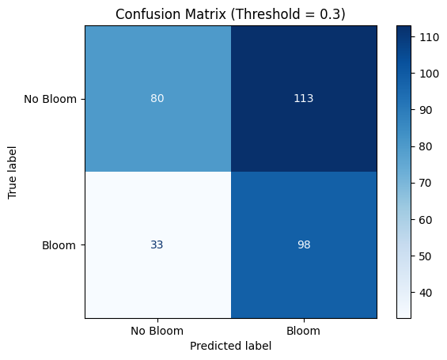

Figure 2. Lowering the classification threshold improves detection of bloom events, reducing false negatives and increasing true positives. However, this comes at the cost of more false positives, indicating increased overprediction of blooms.
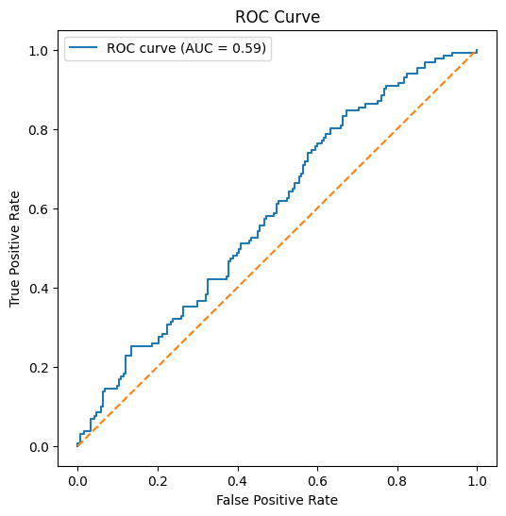
Figure 3. The ROC curve illustrates the model’s ability to distinguish between bloom and non-bloom conditions across thresholds. The area under the curve (AUC) indicates moderate classification performance.
These results suggest that the model contains meaningful predictive signals, but that threshold selection plays a critical role in determining how that signal is translated into actionable predictions.

3.2 Model Interpretability and Feature Influence
SHAP analysis provided insight into the environmental variables driving model predictions. Global SHAP summary plots indicated that water temperature and sea surface height anomaly were the most influential predictors of bloom presence. Wind-related variables are also showing strong contributions, suggesting that mixing and transport processes play a significant role in shaping bloom conditions.
Nutrient variables, including total phosphorus and total nitrogen, contributed to model predictions but were less influential than physical drivers. This suggests that while nutrient availability is important, bloom occurrence in this dataset is more strongly associated with environmental conditions that regulate transport, mixing, and growth dynamics.
Hydrologic input, represented by river discharge, had relatively low influence in this model, indicating that its effect may be indirect or mediated through other variables.
This result may reflect the fact that nutrient availability alone does not determine bloom formation, but instead interacts with physical conditions that control transport, accumulation, and growth.
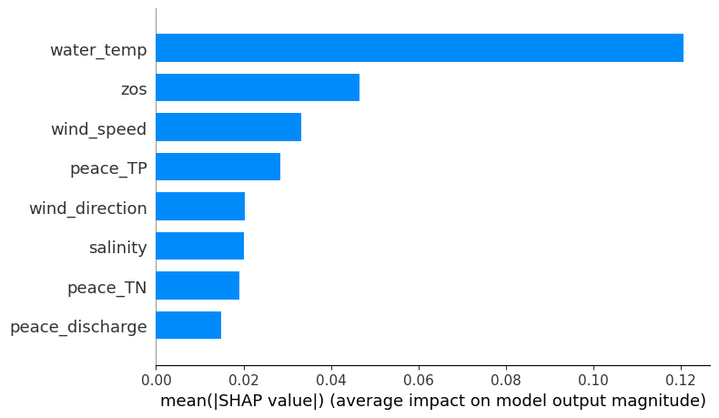

Figure 4. The SHAP summary plot highlights the relative importance and directional influence of each predictor on bloom classification. Physical variables, particularly water temperature and ocean-related conditions, show the strongest impact on model predictions.
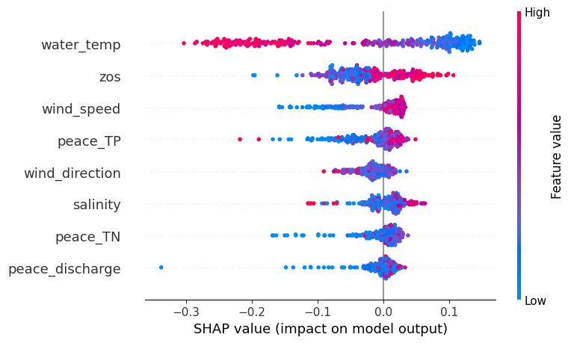
Figure 5. The bar plot displays the average magnitude of feature contributions, confirming that water temperature and physical drivers are the most influential variables. Nutrient variables contribute to predictions but are of secondary importance.
Dependence plots revealed that relationships between nutrient variables and bloom probability were nonlinear rather than strictly increasing. For total nitrogen, low concentrations were associated with negative SHAP values, while moderate concentrations contributed positively to bloom classification. However, this effect leveled off to higher concentrations, suggesting a threshold beyond which additional nitrogen did not further increase bloom probability.
A similar pattern was observed for total phosphorus, where moderate concentrations were associated with the strongest positive contributions to bloom prediction. At both low and very high phosphorus levels, the influence on model output was more variable, indicating that optimal nutrient ranges may exist for bloom development rather than a simple monotonic relationship.
In contrast, river discharge showed relatively weak influence, with most SHAP values near zero and occasional contributions at higher discharge values. This suggests that discharge alone is not a strong direct driver of bloom conditions in this model and may instead influence blooms indirectly through nutrient transport.
Physical variables such as water temperature and salinity exhibited more consistent contributions to model predictions. Temperature showed strong positive associations with bloom probability, reinforcing its role as a key environmental driver, while salinity appeared to have a weaker and more context-dependent effect, potentially interacting with other variables.
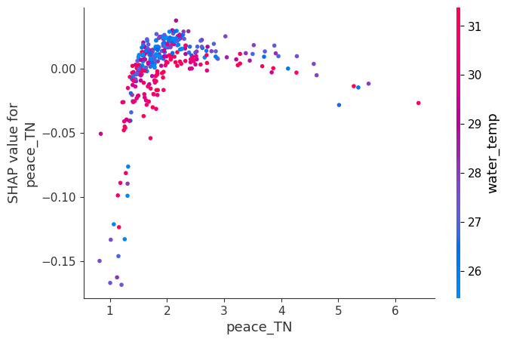
Figure 6. The relationship between total nitrogen and bloom probability is nonlinear, with moderate concentrations contributing most strongly to bloom prediction. At low concentrations, nitrogen has a negative influence, while higher values show a diminishing effect, suggesting a threshold response.
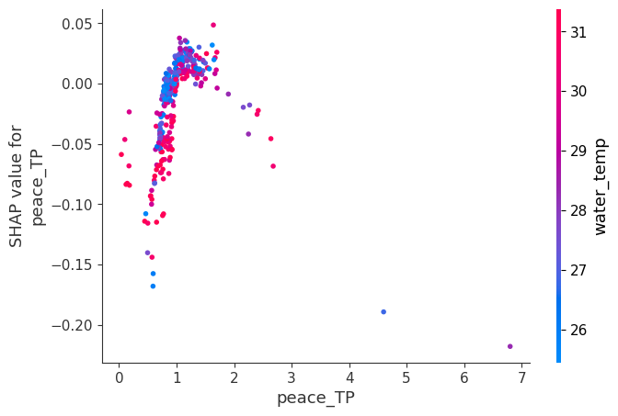

Figure 7. Total phosphorus exhibits a similar nonlinear pattern, where intermediate values are associated with increased bloom probability. At very low or high concentrations, the effect becomes more variable, indicating that optimal nutrient ranges may exist for bloom development.
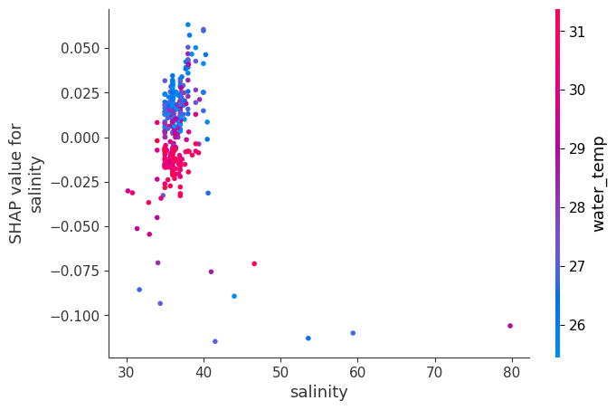

Figure 8. This plot shows that physical environmental conditions influence bloom probability in a variable and context-dependent manner. The spread of SHAP values suggests interactions with other factors rather than a simple direct relationship.
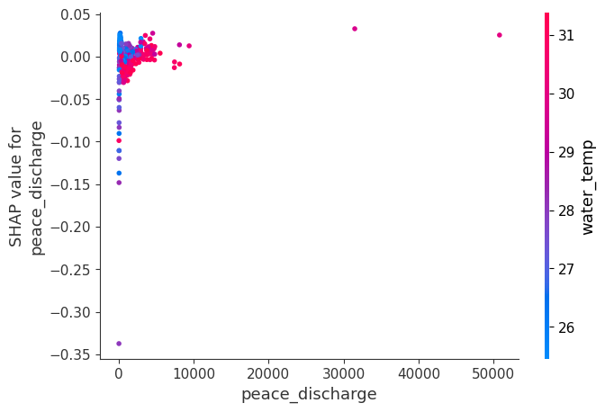
Figure 9. River discharge shows a relatively weak and inconsistent influence on bloom prediction, with most values clustered near zero contribution. Occasional negative SHAP values suggest that higher discharge may reduce bloom likelihood in some cases, possibly through dilution or flushing effects.

3.3 Effect of Lagged Environmental Variables
Incorporating lagged predictors altered model’s classification behavior, particularly in its ability to detect bloom events. The inclusion of 1-week lag variables for total nitrogen, total phosphorus, and water temperature increased the number of collectively identified bloom observations, indicating improved sensitivity to bloom conditions.
However, this improvement in bloom detection came with a noticeable increase in false positives. The lagged model classified many non-bloom observations as blooms, suggesting that while the model became more responsive to bloom-related signals, it did so at the expense of precision. This tradeoff highlights the challenge of balancing sensitivity and specificity in environmental prediction models.
These results suggest that bloom formation is influenced by prior environmental conditions, supporting the idea that HAB development reflects delayed ecological response to nutrient loading and thermal conditions. At the same time, the increase in false positives indicates that incorporating temporal variables may amplify signals that are not exclusively associated with bloom events.
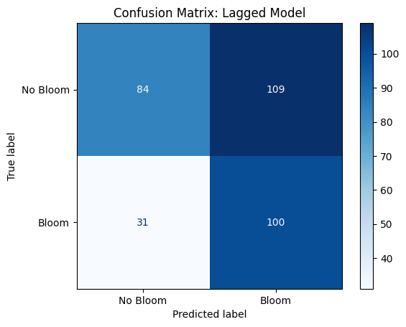
Figure 10. The confusion matrix for the lagged model with SMOTE oversampling shows the highest detection of bloom events, as indicated by increased true positives and reduced false negatives. However, this improvement is accompanied by a substantial increase in false positives, reflecting a strong tendency toward overprediction of bloom conditions.
Overall, the lagged model demonstrates that temporal structure can improve bloom detection, but careful consideration is needed to manage overprediction and maintain model reliability.

3.4 Impact of SMOTE Oversampling
Applying SMOTE to the lagged training dataset further improved the model’s ability to detect bloom events. The SMOTE-balanced model showed increased recall for the bloom class compared to both the baseline and lagged-only models, indicating that oversampling helped the model better learn patterns associated with bloom conditions.
However, this improvement was accompanied by an increase in false positives, reflected in lower precision. This tradeoff highlights the challenge of balancing sensitivity and specificity in imbalanced detection of rare events; it can also lead to overprediction if not carefully evaluated.
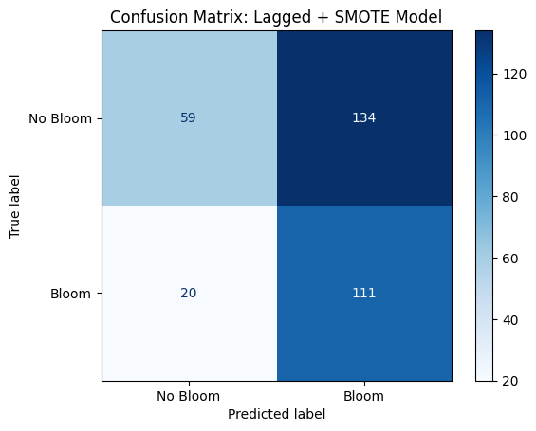
Figure 11. The confusion matrix for the lagged model with SMOTE oversampling demonstrates the highest bloom detection performance across all model configurations, with fewer missed bloom events. However, this improvement is accompanied by a substantial increase in false positives, indicating a strong tendency toward overprediction and reduced precision.
Despite this tradeoff, the SMOTE-enhanced model may be more appropriate in applications where the cost of missing bloom events is high, such as public health or fisheries management.

3.5 Comparison Model Performance
Comparison across all model configurations revealed clear trade-offs among accuracy, recall, and precision. The baseline model using a 0.50 threshold provided balanced performance but under detected bloom events, as reflected in relatively low recall.
Lowering the classification threshold to 0.30 substantially improved recall, allowing the model to detect a greater number of bloom events, while precision remained relatively similar. This indicates that threshold adjustment alone was effective in improving bloom detection without significantly increasing classification error.
Incorporating lagged variables further improved model performance, as reflected in increased ROC-AUC and a slight improvement in recall. This suggests that including temporal information enhanced the model’s ability to capture underlying environmental processes associated with bloom formation.

The addition of SMOTE produced the highest recall and ROC-AUC across all model configurations, indicating the strongest ability to detect bloom events. However, this improvement came at the cost of reduced precision, as the model increasingly classified non-bloom observations as blooms.
 | Model | Accuracy | ROC_AUC | Precision | Recall | F1
0 | Baseline (0.50 threshold) | 0.558642 | 0.590080 | 0.456522 | 0.480916 | 0.468401
1 | Baseline (0.30 threshold) | 0.549383 | 0.590080 | 0.464455 | 0.748092 | 0.573099
2 | Lagged model (0.30 threshold) | 0.567901 | 0.618874 | 0.478469 | 0.763359 | 0.588235
3 | Lagged + SMOTE (0.30 threshold) | 0.524691 | 0.644465 | 0.453061 | 0.847328 | 0.590426

Table 1. Comparison of model performance across all configurations, including baseline, threshold-adjusted, lagged, and SMOTE-enhanced models. Metrics include accuracy, ROC-AUC, precision, recall, and F1-score, illustrating tradeoffs between overall performance and bloom detection sensitivity.
These results demonstrate that no single model configuration is universally optimal. Instead, model selection depends on the intended application. For early warning systems, models with higher recall may be preferred, while for regulatory applications, precision may be more important to avoid false alarms.

3.6 Environmental Interpretation and Implications
The results of this study highlight the importance of physical environmental conditions shaping harmful algal bloom dynamics nearshore. While nutrient variables contributed to model predictions, SHAP analysis indicated that factors such as water temperature and ocean conditions had a stronger influence on bloom occurrence. This suggests that nutrient availability alone may not be sufficient to drive bloom formation, but instead interacts with physical processes that regulate transport, mixing, and growth.
The improved performance of lagged models further supports the role of temporal dynamics, indicating that bloom development reflects delayed responses to environmental conditions rather than immediate input alone. This has important implications for monitoring and prediction, as it suggests that early warning systems should incorporate prior environmental conditions to improve forecasting accuracy.
From a management perspective, the tradeoffs observed across model configurations highlight the need to align model selection with application goals. Models optimized for high recall may be more appropriate for early warning systems where missing bloom events are costly, while models with higher precision may be better suited for regulatory decision-making where false alarms must be minimized.

4. Conclusions
The results of this study highlight the importance of physical environmental conditions in shaping harmful algal bloom dynamics nearshore. While nutrient variables contributed to model predictions, SHAP analysis indicated that factors such as water temperature and ocean conditions had a stronger influence on bloom occurrence. This suggests that nutrient availability alone may not be sufficient to drive bloom formation, but instead interacts with physical processes that regulate transport, mixing, and growth.
The improved performance of lagged models further supports the role of temporal dynamics, indicating that bloom development reflects delayed responses to environmental conditions rather than immediate input alone. This has important implications for monitoring and prediction, as it suggests that early warning systems should incorporate prior environmental conditions to improve forecasting accuracy.
From a management perspective, the tradeoffs observed across model configurations highlight the need to align model selection with application goals. Models optimized for high recall may be more appropriate for early warning systems where missing bloom events are costly, while models with higher precision may be better suited for regulatory decision-making where false alarms must be minimized.

Data availability statement (containing link to your code, presentation, and report repository)

All data, code, and analysis used in this study are publicly available at:
https://github.com/avaghannam/Environmental-Data-Science-Final-Project
The repository contains the full modeling workflow, including data preprocessing, model implementation, evaluation, and visualization scripts, as well as the final report and presentation materials. (Presentation coming soon)

References
Florida Fish and Wildlife Conservation Commission. “Effects of Florida’s Red Tide on Marine Animals.” Florida Fish and Wildlife Conservation Commission, myfwc.com/research/redtide/general/marine-animals/.

National Ocean Service. “What Is a Red Tide?” Noaa.gov, NOAA, 16 June 2024, oceanservice.noaa.gov/facts/redtide.html. Accessed 3 Mar. 2026.

National Oceanic and Atmospheric Administration. “Harmful Algal Blooms.” NOAA, oceanservice.noaa.gov/hazards/hab/.

United States Environmental Protection Agency. “Nutrient Pollution: The Problem.” U.S. Environmental Protection Agency, www.epa.gov/nutrientpollution/problem.

Florida Fish and Wildlife Conservation Commission. “Florida Red Tide.” Florida Fish and Wildlife Conservation Commission, myfwc.com/research/redtide/.

Anderson, Donald M., et al. “Harmful Algal Blooms and Eutrophication: Nutrient Sources, Composition, and Consequences.” Estuaries, vol. 25, no. 4, 2002, pp. 704–726.

Florida Fish and Wildlife Conservation Commission. “Effects of Florida’s Red Tide on Marine
Animals.” Florida Fish and Wildlife Conservation Commission, myfwc.com/research/redtide/general/marine-animals/.

National Ocean Service. “What Is a Red Tide?” Noaa.gov, NOAA, 16 June 2024, oceanservice.noaa.gov/facts/redtide.html. Accessed 3 Mar. 2026.

National Oceanic and Atmospheric Administration. “Harmful Algal Blooms.” NOAA,
oceanservice.noaa.gov/hazards/hab/.
United States Environmental Protection Agency. “Nutrient Pollution: The Problem.” U.S. Environmental Protection Agency,
www.epa.gov/nutrientpollution/problem.
Florida Fish and Wildlife Conservation Commission. “Florida Red Tide.” Florida Fish and Wildlife Conservation Commission,
myfwc.com/research/redtide/.
Anderson, Donald M., et al. “Harmful Algal Blooms and Eutrophication: Nutrient Sources, Composition, and Consequences.”
Estuaries, vol. 25, no. 4, 2002, pp. 704–726.
NOAA Fisheries. “Hitting Us Where It Hurts: The Untold Story of Harmful Algal Blooms | NOAA Fisheries.” NOAA, 10 Dec. 2020, www.fisheries.noaa.gov/west-coast/science-data/hitting-us-where-it-hurts-untold-story-harmful-algal-blooms.

Appendix (if needed)

